File 18_azone_veh_use_taxes.csv
March 23, 2026
Definition of the Input File
VisionEval (https://visioneval.github.io/docs/model-inputs.html) explains that the azone_veh_use_taxes file has three attributes—the fuel tax per gallon, a tax on vehicle-miles traveled, and “PevSurchgTaxProp” which is the proportion of the gas tax levied on plug-in electric vehicles. For example, suppose a gas-powered vehicle will pay $229.22 in fuel taxes over a year. A plug-in electric vehicle requires no fuel and thus “PevSurchgTaxProp” would be zero—except that in Virginia, all electric vehicles pay a fee of $131.88. Thus “PevSurchgTaxProp” is 131.88/229.22 or about 0.575. Generally, it is presumed that in real (2024) dollars there will not be a change in either of these taxes.
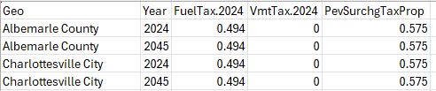

Possible Scenario
One possible scenario in VisionEval based on this input file is to examine how changing the tax influences daily vehicle miles traveled and use of other modes, especially with respect to impacts on electric vehicle travel and hence greenhouse gas emissions.
As is the case with another input (azone_hh_veh_own_taxes), the document Task 7.2 Simplified Scenario Development guide is available at A Playbook for Simplified Approaches for Creating Scenarios in VisionEval further explains that because these “increase the cost of single occupancy vehicle travel” that one might explore “how increases in fuel taxes would impact the amount of vehicle miles traveled, the number of biking, walking, and transit trips, as well as CO2e emissions from single occupancy vehicles.” For example, the guide notes that “Per mile fees that have been implemented by DOTs across the U.S. have been less than one dollar – typically between 1 and 3 cents.”
Method Used for Virginia Statewide
For the three attributes, data were estimated as follows:
- Fuel tax. For the period July 1, 2024-June 30, 2025 Virginia fuel taxes were 30.8 cents per gallon (for gasoline) and 31.8 cents per gallon (for diesel) and have been reported by FHWA as 31 cents per gallon. The federal tax is 18.4 cents per gallon. Thus in 2024 dollars, the fuels tax per gallon is reported in VisionEval for 2024 as 31.0 cents (roughly for regular fuel or diesel) + 18.4 cents = 49.4 cents per gallon. This value is left the same for year 2024 and 2045 as both costs are in 2024 dollars. These are based on sources 1-4 below.

- VMT tax. Virginia does not have a VMT tax so this value is zero.

- PevSurchgTaxProp represents a surcharge on electric vehicles designed to capture this fuels tax. In 2025, the highway use fee for electric vehicles was $131.88 as shown in source 5. The base scenario assumes that the Virginia Department of Motor Vehicles will adjust the fee periodically adjust for inflation. For a gas vehicle that gets 25 miles per gallon and drives an average of 11,600 miles per year, that vehicle would spend 11,600 miles/25 gallons * tax of 49.4 cents per gallon = $229.22 per year. Thus, the electric vehicle pays $131.88/$229.22 = 0.575 of the gas tax cost.

Local planners may modify these values. For instance, if a region includes a supplemental tax for transportation, this would be added to the base (2024) year.
Sources:
- Department of Motor Vehicles. Fuels Tax Rates and Alternative Fuels Conversion. https://www.dmv.virginia.gov/businesses/tax-act/fuels/tax-rates
- FHWA. https://www.fhwa.dot.gov/policyinformation/statistics/2024/mf205.cfm
- FHWA. https://www.fhwa.dot.gov/policyinformation/statistics/2024/fe21b.cfm
- https://www.dmv.virginia.gov/vehicles/taxes-fees/highway-use
- https://www.dmv.virginia.gov/sites/default/files/documents/HUF-fee-2025.pdf
SCRAP work
Source 1
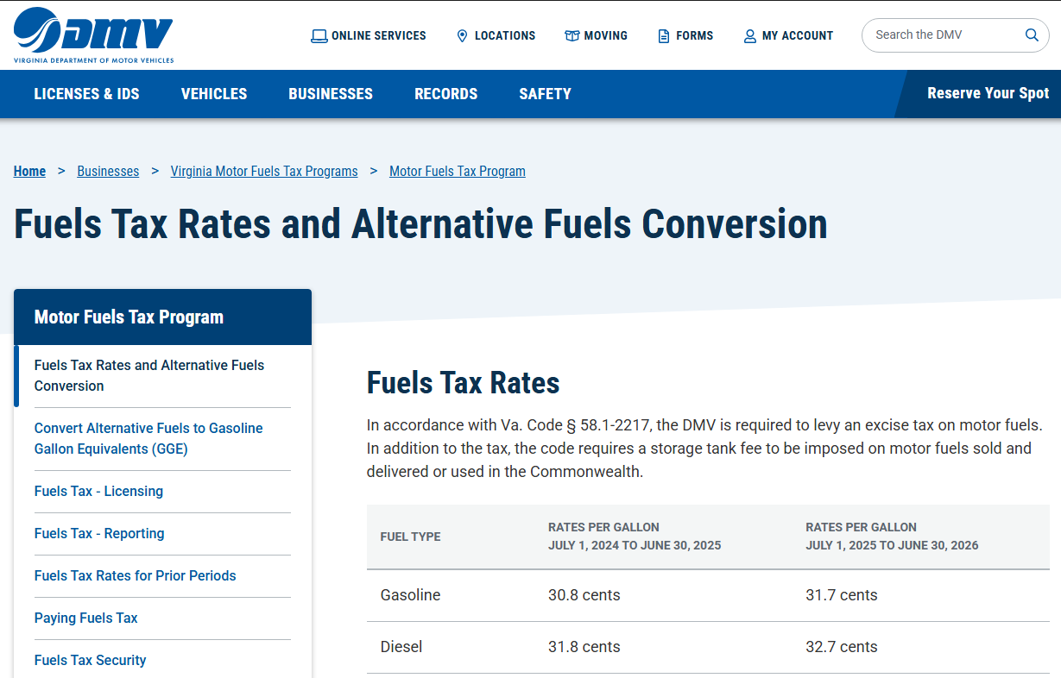

Source 2
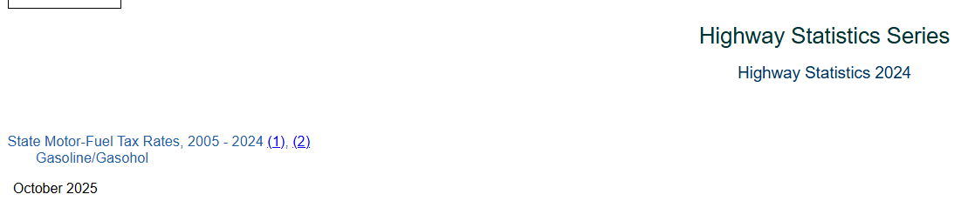
Source 3
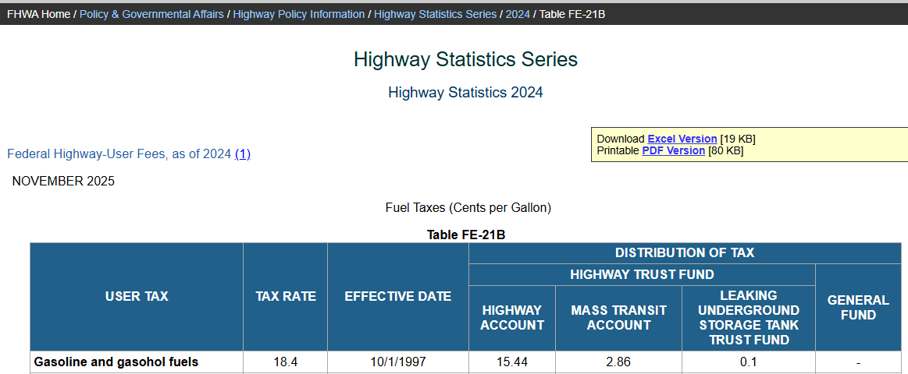

Source 4

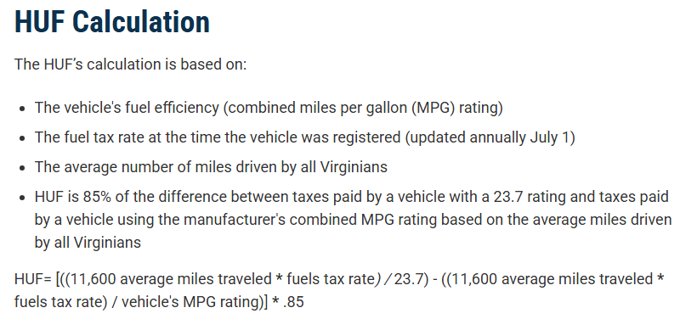
Source 5
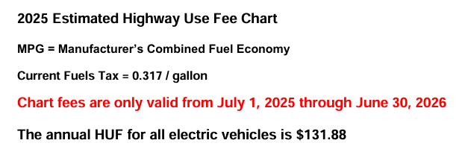
\\501-RC-NAS1\Users\John.Miller\Current\VisionEvalNova\RunningInR\RedoBaseScenarios.xlsx

